CHAPTER -Electricity

Q1 An electric generator converts
- Electric Energy into sound energy
- Electric Energy into light energy
- Electric Energy into mechanical energy
- Mechanical Energy into electric energy

Q2 The wire used in the filaments of household bulbs has
- High resistance, high melting point
- High resistance, low melting point
- Low resistance, high melting point
- Low resistance, Low melting point
Q3 The device that changes the voltage of an electric power supply is
- Potentiometer
- Transformer
- Voltmeter
- battery

Q4 The heating element of an electric iron is made of
- iron
- tungsten
- nichrome
- copper

Q5 A tube light works on the principle of
- chemical effect of current
- magnetic effect of current
- heating effect of current
- discharge of electrons through gases
Q6 The work done in moving a unit positive charge across two points in an electric circuit is the measure of
- potential difference
- electrostatic force
- current
- power
Q7 In electric supply lines in india ,which parameter is kept constant[CDS 2007]
- Voltage
- Current
- Frequency
- Power

Q8 The main power supply in india is at 220 V ,whereas that in the US is at 110 V .Which among the following statement is correct [NDA- 2012]
- 110 V is safer but more expensive to maintain
- 110 V is safer but more cheaper to maintain
- 110 V leads to lower power loss
- 110 works better at higher latitudes
Q9 The resistance of a wire of length l and area of cross section a is x ohm.If the wire is stretched to double its length ,its resistance would become [NDA-2015]
- 2x ohm
- 0.5xohm
- 4xohm
- 6xohm
Q10 A given conductor carrying a current I ampere .It produces an amount of heat equal to 2000J .The current through the conductor is double the amount of heat produced will be [NDA-2016]

- 2000J
- 4000J
- 8000J
- 1000J

Q11 A simple circuit contains a 12 V battery and a bulb having 24 ohm resistance .When turn on the switch the ammeter connected to the circuit would read [NDA 2016]
- 0.5 A
- 2A
- 4A
- 5A

Q12 Three resistors with magnitudes 2 ohm,4ohm and 8 ohm are connected to parallel, equivalent resistance of the system would be [NDA 2016]
- Less than 2 ohm
- More than 2 ohm but less than 4 ohm
- 4ohm
- 14 ohm

Q13 If a free electron moves through a potential difference of 1 Kv,then the energy gained by the electron is given by[NDA 2018]
- 1.6x10⁻¹⁹J
- 1.6x10⁻¹⁶J
- 1x10⁻¹⁹J
- 1x10⁻¹⁶J

Q14 Consider the following circuit
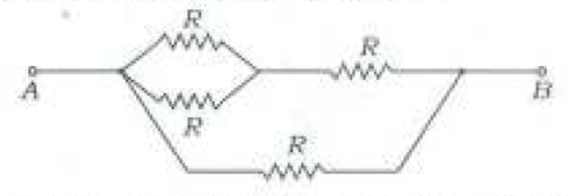
Which is the effective resistance between A and B[NDA2018]
- 2R/5
- 3R/5
- 3R/2
- 4R
Q15 The graphs between current (I) and Voltage (V) for three linear resistors 1,2 and 3 are given below
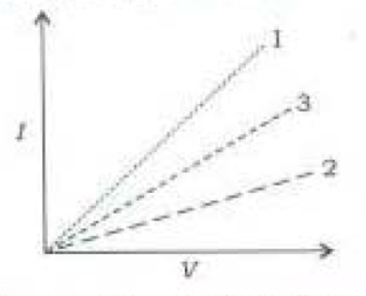
If R1 ,R2 and R3 are the resistances of these resistors ,then which of the following is correct[NDA 2018]
- R1>R2>R3
- R1<R3<R2
- R3<R1<R2
- R3>R2>R1
Q16 The unit of resistivity is
(a) ohm
(b) ohm meter
(c) ohm metre⁻¹
(d) mho metre⁻¹

Q17 A wire of resistance R is cut into n equal parts. These parts are then connected in parallel. The equivalent resistance of combination will be :
- nR
- R/n
- n/R
- R/n²

Q18 Three resistance each of 8Ω are connected to a triangle. The resistance between any two terminal will be:
- 12ohm
- 24ohm
- 2ohm
- 16/3ohm

Q19 In how many parts(equal) a wire of 100Ω be cut so that a resistance of 1Ω is obtained by connecting them in parallel ?
- 10
- 100
- 20
- 50
Q20 The filament of an electric bulb is made of tungsten because :
- its resistance is negligible
- it is cheaper
- its melting point is high
- its filament is easily made

Q21 In the given circuit, the effective resistance between points A and C will be :
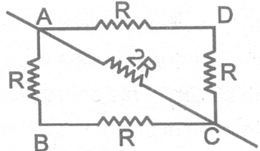
- 3R
- 3R/2
- 2R/3
- None of these

Q22 A fuse wire is always connected to the :
- neutral wire
- earth wire
- live wire
- none of these

Q23 The wire having a red plastic covering is a :
- live wire
- neutral wire
- earth wire
- none of these

Q24 A switch is always connected to the
- earth wire
- neutral wire
- live wire
- none of these

Q25 High power electrical appliances are earthed to
- avoid shock
- avoid wastage
- Make the appliance look beautiful
- reduce the bill

Q26 If the current I through a resistor is increased by 100% the increased in power dissipation will be (assume temperature remain unchanged)
(a) 100%
(b) 200%
(c) 300%
(d) 400%

Q27 An electric bulb is rated 220 V and 100 W. When it is operated on 110 V, the power
consumed will be:
(a) 100 W
(b) 75 W
(c) 50 W
(d) 25 W

Q28 Find the current flowing through 3 Ω .

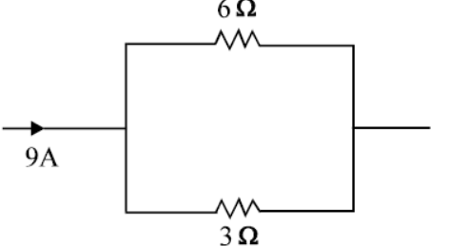
- 3 Α
- 6 Α
- 9 Α
- 12 Α
Q29 Find the equivalent resistance across A & B.
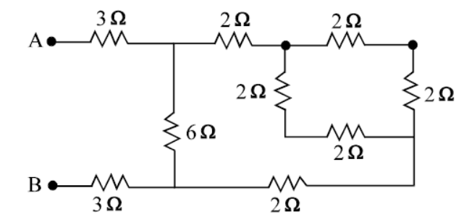
- 3 Ω
- 6 Ω
- 9 Ω
- 12 Ω

Q30 A 3 volt battery with negligible internal
resistance is connected in a circuit as shown
in the figure. The current I, in the circuit
will be

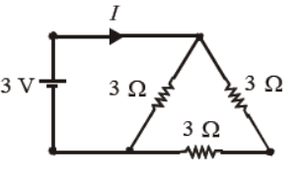

(a) 1 A
(b) 1.5 A
(c) 2 A
(d) (1/3) A
Q31 Working of safety fuses depends upon
1)Magnetic effects of the current
2)Chemical effects of the current
3)Magnitude of the current
4)Heating effect of the current

Select the correct answer using the code given below[CDS 2018I]

- 1,2,3 and 4
- 1,2 and 3 only
- 3 and 4 only
- 4 only
Q32 Two metallic wires made from copper have same length but the radius of wire 1 is half of that of wire 2.The resistance of wire 1 is R .If both the wires are joined together in series, the total resistance becomes[CDS 2018]
(a) 2R
(b) R/2
(c) 5R/4
(d) 3R/4

Q33 A wire of copper having length l and area of cross section A is taken and a current I is flown through it.The power dissipated in the wire is P.If we take an aluminium wire having same dimensions and pass the same current through it ,the power dissipated will be [CDS 2018]
- P
- <p
- >p
- 2P

Q34 Suppose voltage V is applied across a resistance R.The power dissipated in the resistance is P. Now the same voltage V is applied across a parallel combination of three equal resistors each of resistance R.Then the power dissipated in the second case will be [CDS 2017]
(a) P
(b) 3P
(c) P/3
(d) 2P/3

Q35 A copper wire of radius r and length l has a resistance of R .A second copper wire with radius 2r and length l is taken and the two wires are joined in a parallel combination .The resultant resistance of the parallel combination of the two wires will be [CDS 2017]
- 5R
- 5R/4
- 4R/5
- R/5
Q36 Two wires are made having same length l and area of cross section wire 1 is made of copper and wire 2 is made of aluminium .It is given that electrical conductivity of copper is more than that of aluminium .In this context ,which one of the following statement is correct [CDS 2017 II]
- The resistance of wire 1 will be higher than that of wire 2
- The resistance of wire 2 will be higher than that of wire 1
- The resistance of both wire will be same
- If same current is flown through both the wires ,the power dissipated in both the wires will be same

Q37 Electricity is produced through dry cell from[CDS 2015]
- Chemical energy
- Thermal energy
- Mechanical energy
- Nuclear energy

